# watsonx Orchestrate Lab XX:

# Building an Assistant

Objective

In this lab, you will learn how to set up an Assistant using Assistant Builder in watsonx Orchestrate. We will be creating the Initiate Replenishment flow using the current inventory data, historic and forecasted sales.

Use Case:

In this lab, you will learn how to configure an Assistant to initiate replenishment of a Product.

The high-level steps to accomplish this are as follows:

1. Build custom extensions to retrieve historic and forecast sales.

2. Connect with Salesforce to get current inventory data.

3. Calculate optimal reorder quantity with CrewAI agent.

4. Test the Assistant.

## Create Initiate Replenishment Assistant

1. Start by creating an Assistant in the AI Assistant Builder

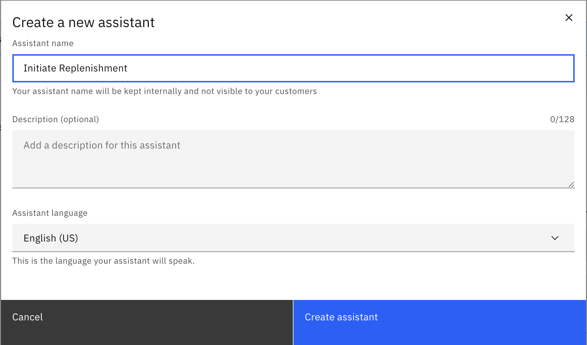

1. Go to Skill Sets, and from the dropdown, select “Initiate Replenishment draft” and move to the Connections tab.

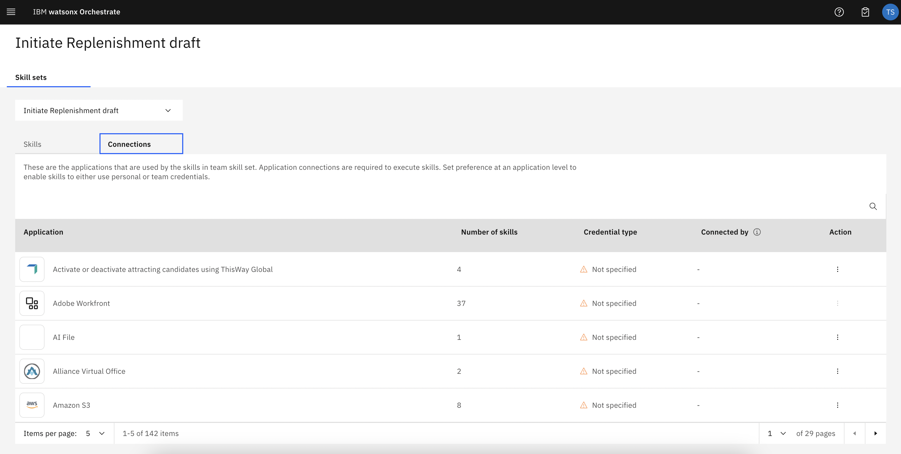

1. Search for “Salesforce” skill and connect the application using the below credentials:
   1. Select Team Credentials
   2. You will be prompted to enter Custom URL. Skip and select “Update App”
   3. Enter the username and password:

Username: [orchestrate.workshop.apac@gmail.com](mailto:orchestrate.workshop.apac@gmail.com)

Password: Watsonxorchestrate321

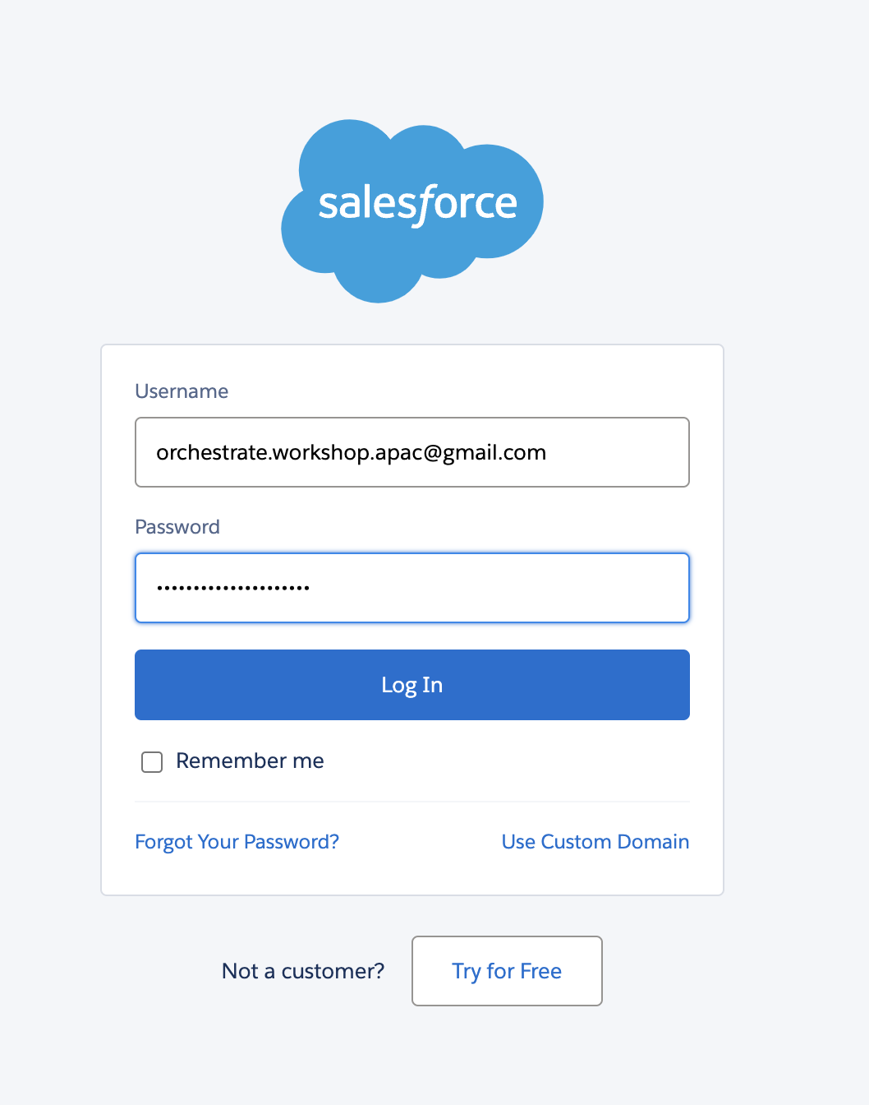

* 1. Click on “Allow” to allow all access

1. Search for “Get Historic Sales” and connect the application using the below credentials:

Username: test

Password: test

1. Search for “Time Series Forecasting” and connect the application using the same credentials as mentioned in Step 4.
2. Search for “Calculate Reorder Quantity” and connect the application using the same credentials as mentioned in Step 4.
3. Go to AI Assistant Builder and select the “Initiate Replenishment Assistant”



1. Go to “Action” click “Create Action” and choose “Skill based Actions”

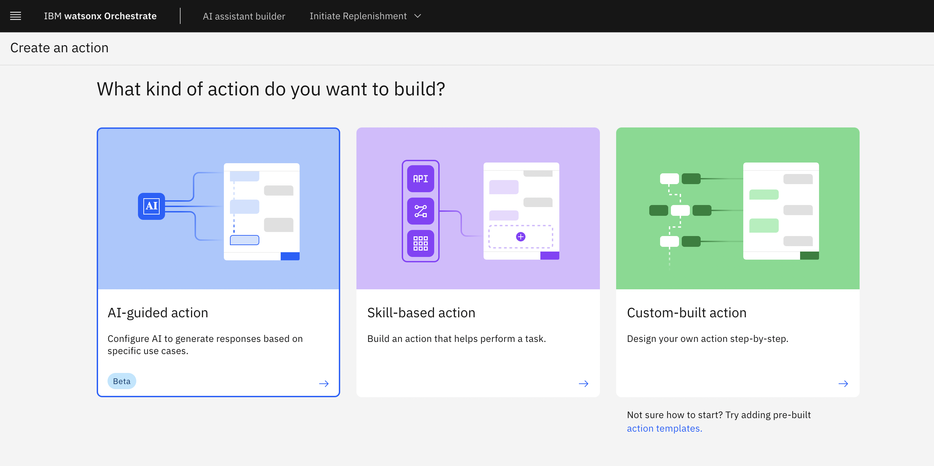

1. Start adding the following skills one by one.
   1. Get all Products
   2. Text2SQL with CrewAI
   3. Time Series Forecasting
   4. Optimal Reorder Quantity

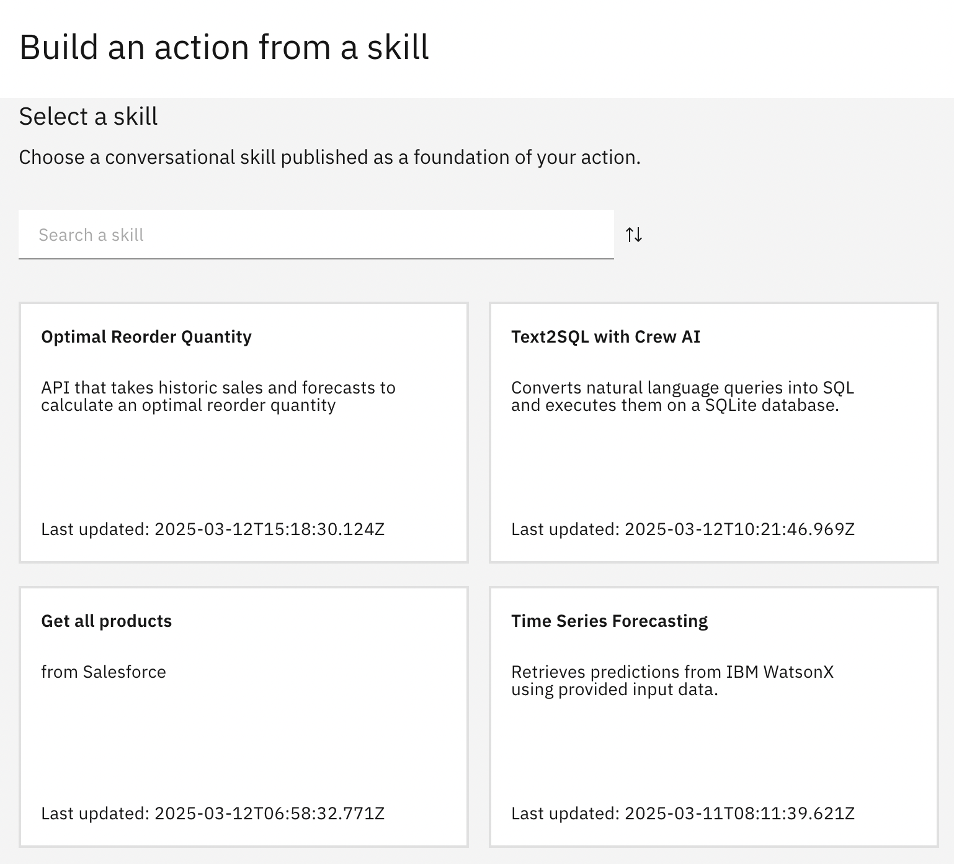

1. Once all the 4 skills have been added, the Actions tab will look like this

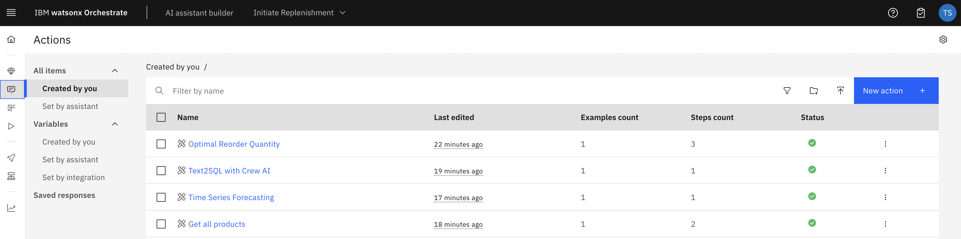

1. Click on “New Action” and select Custom-built Action. Name the Action “Initiate Replenishment”

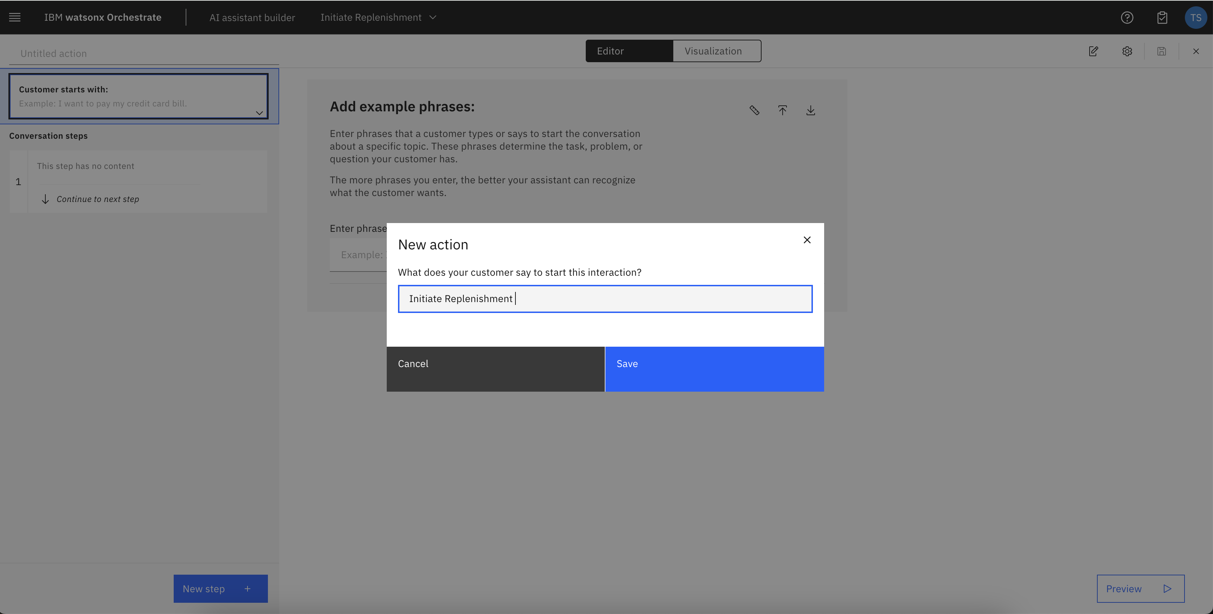

1. In the Step 1, add the following details to use Salesforce:
   1. Assistant says: Fetching current inventory
   2. And then: Go to Sub action > Get all Products

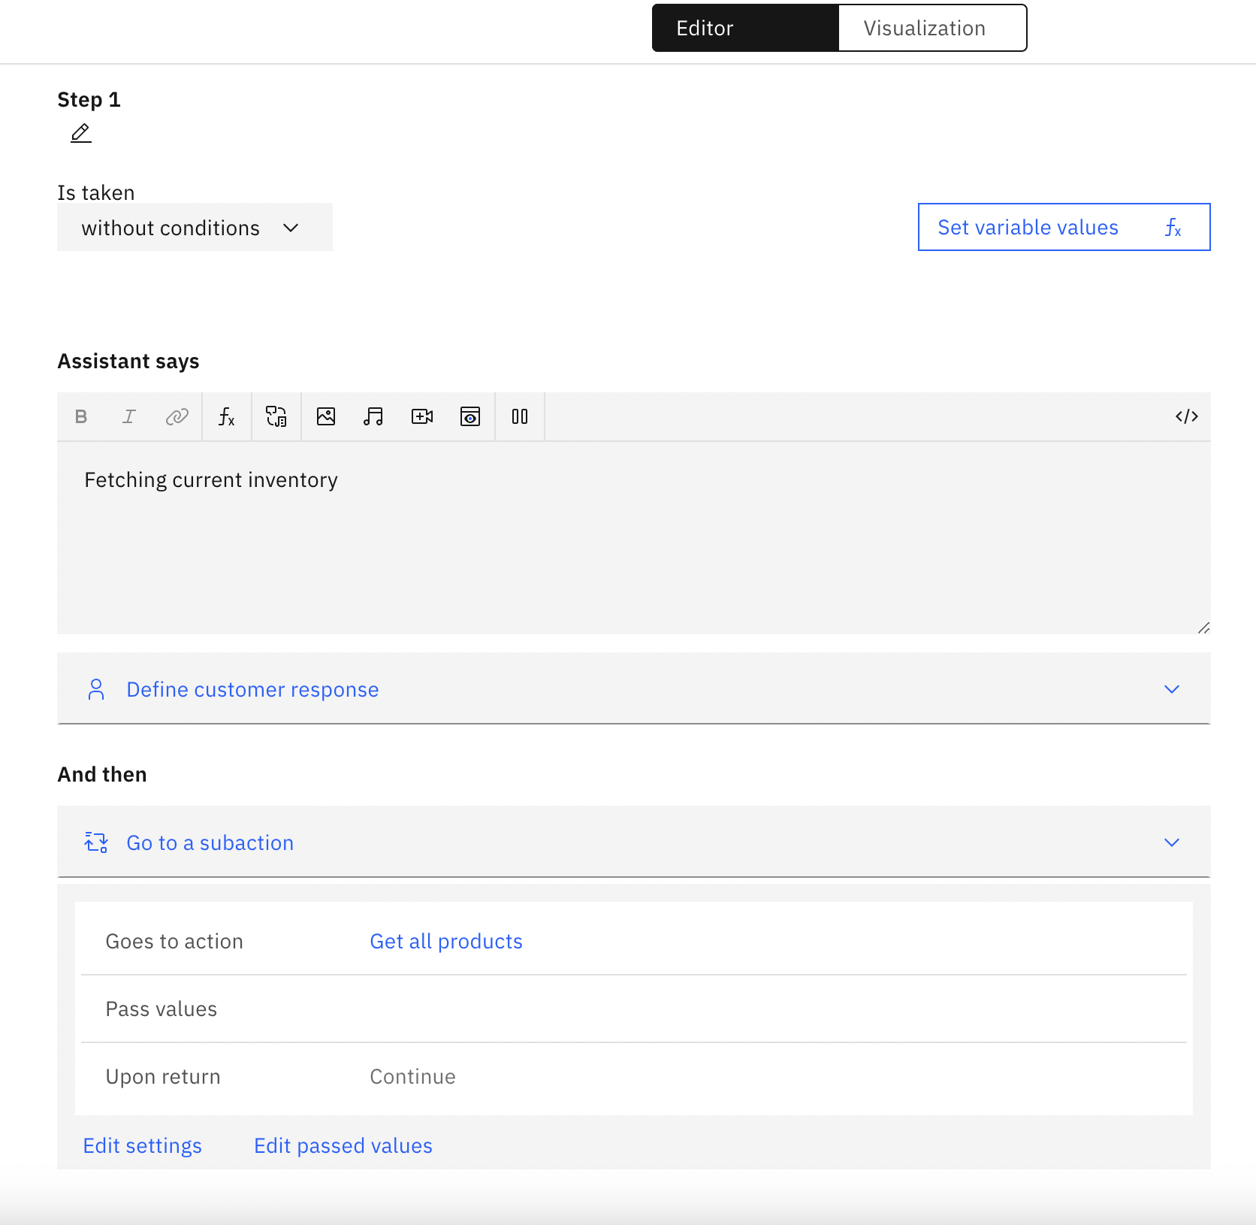

1. In the Step 2, add the following details to fetch Historic Sales:
   1. Assistant says: Fetching Historic Sales
   2. And then: Go to Sub action > Text2SQL with CrewAI

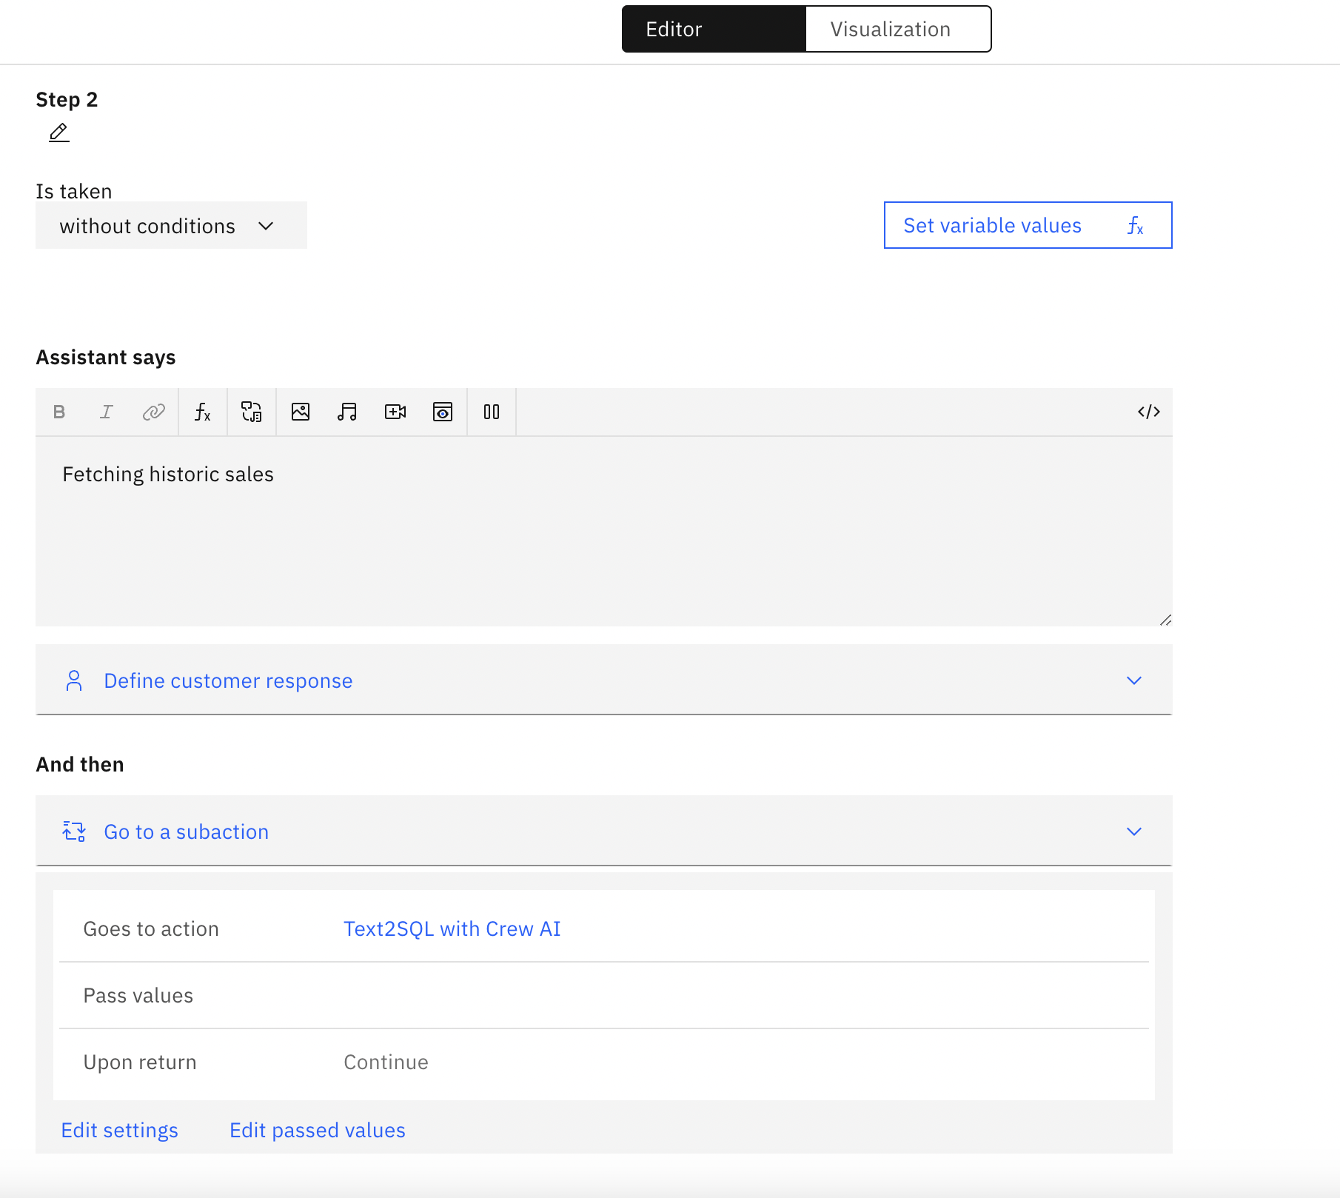

1. In the Step 3, add the following details to fetch Forecasted Sales:
   1. Assistant says: Fetching Forecasted Sales
   2. And then: Go to Sub action > Time Series Forecasting

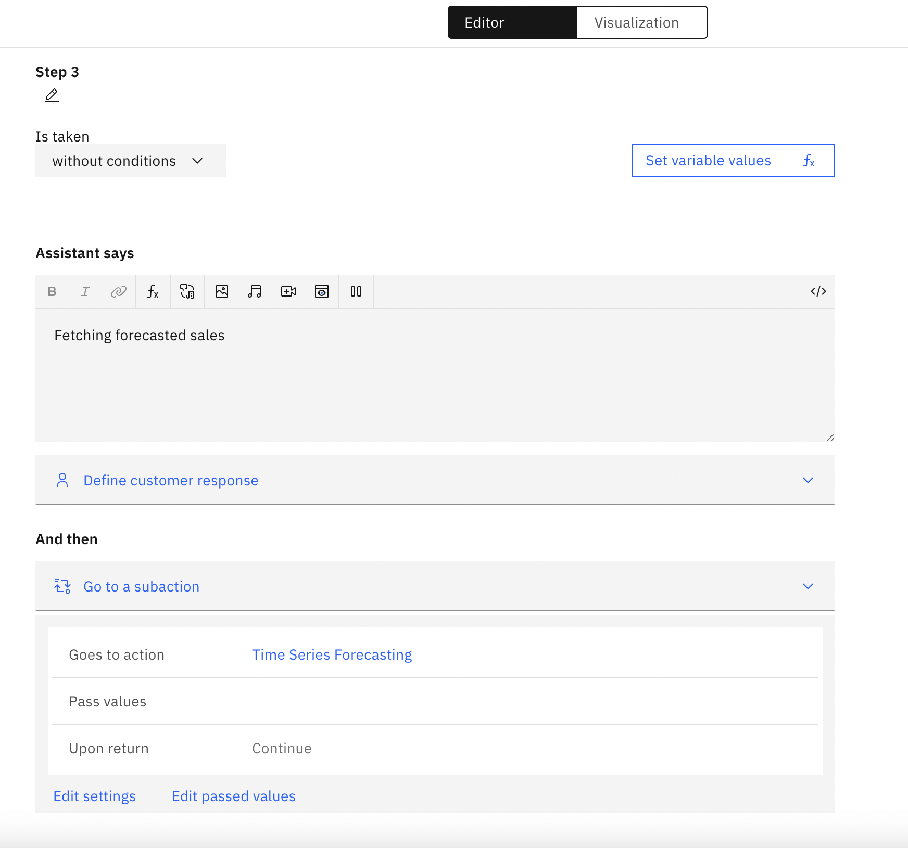

1. In the Step 4, add the following details to calculate Reorder Quantity:
   1. Assistant says: Calculating optimal reorder quantity
   2. And then: Go to Sub action > Optimal Reorder Quantity

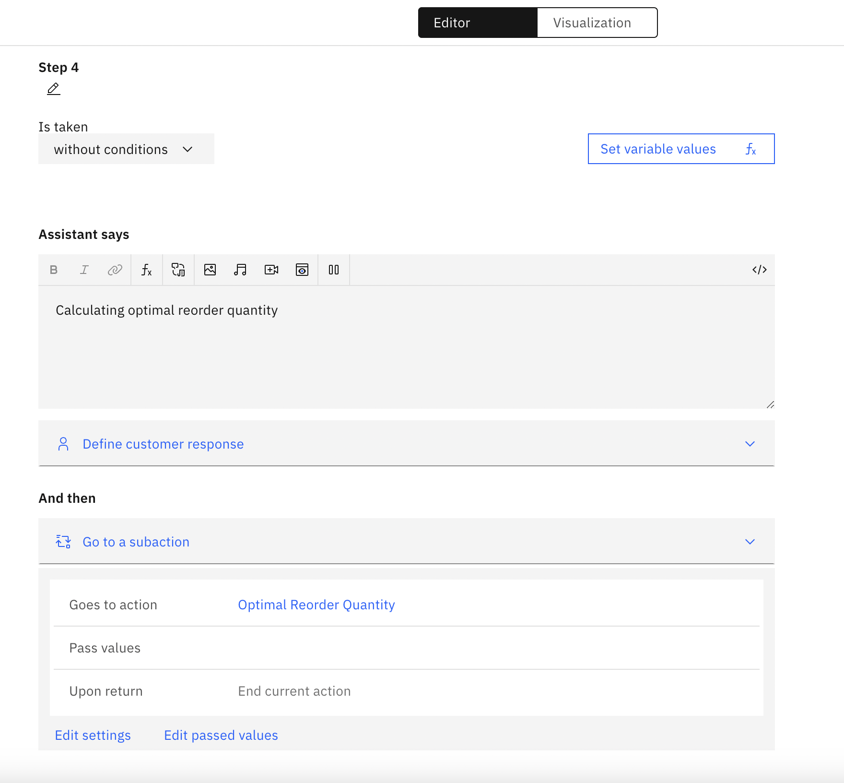

1. Once all the 4 steps are complete, the Initiate Replenishment Action will look like this:

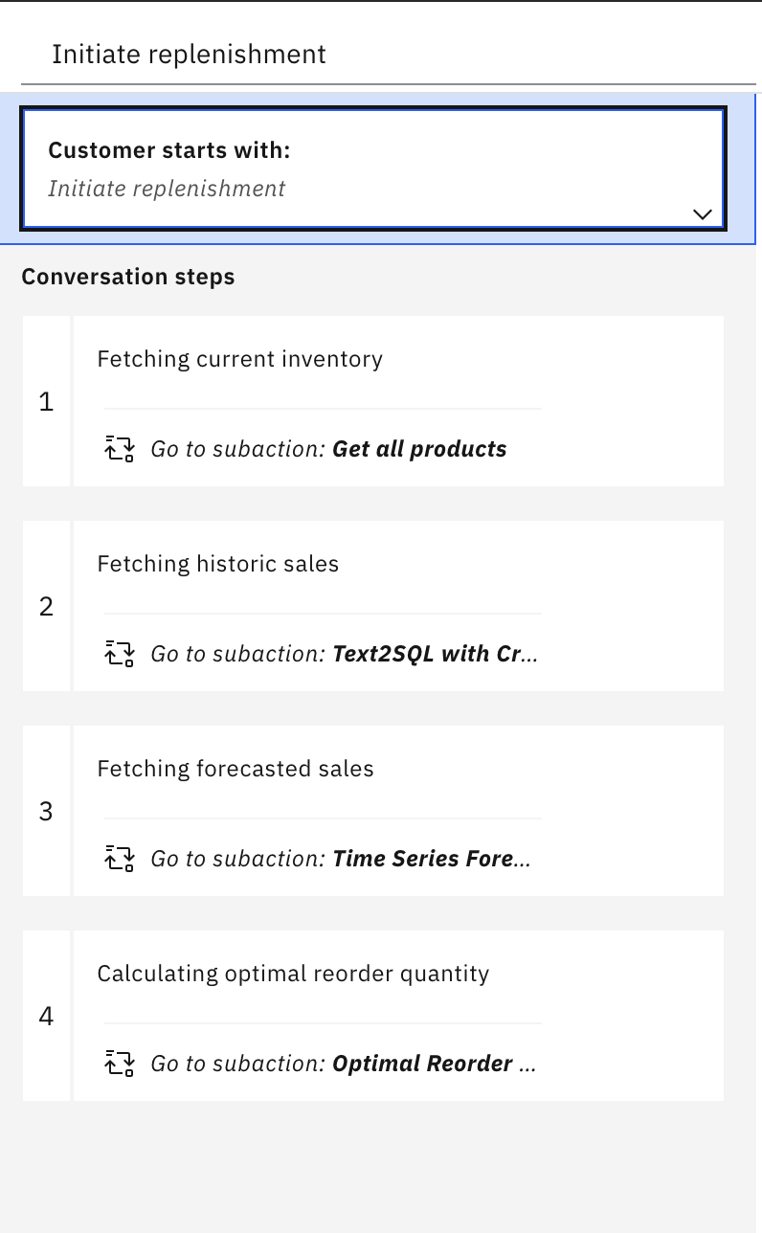

## Test Initiate Replenishment Assistant

1. Go to Preview tab, and Test the Skill by selecting “Initiate Replenishment”

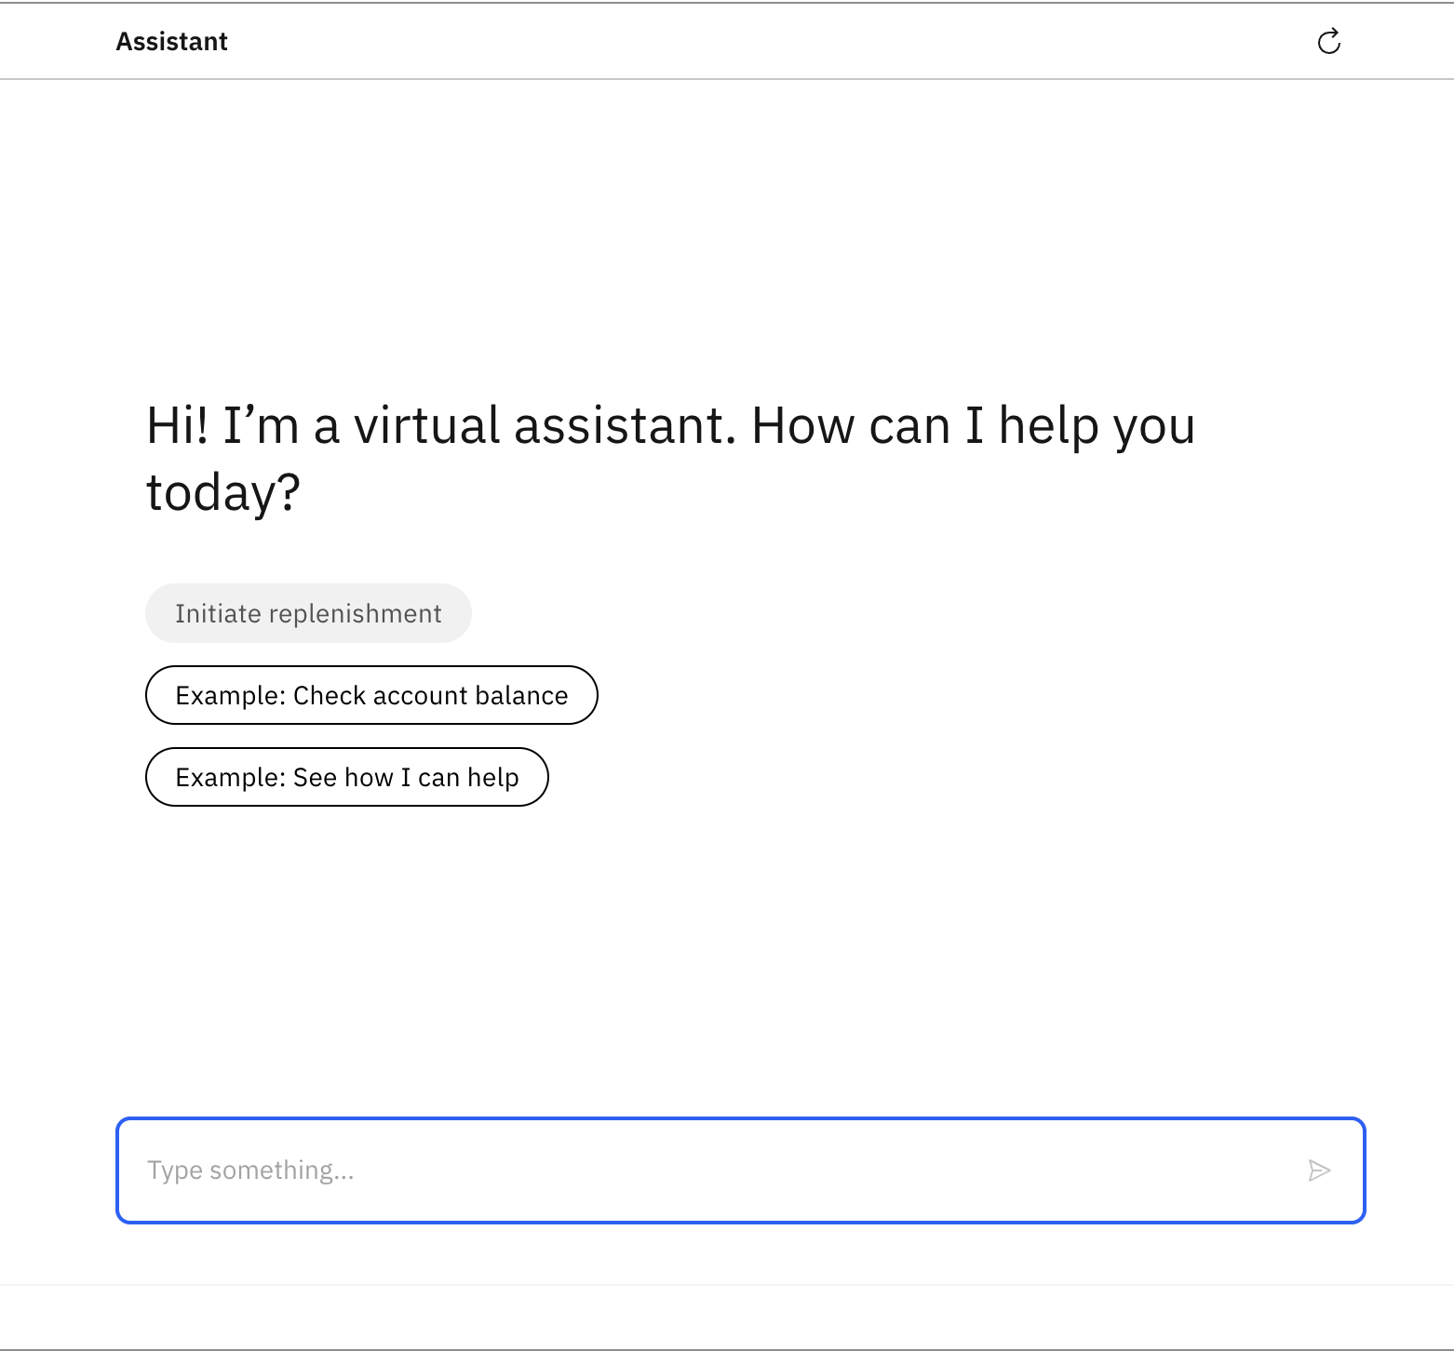

1. Add filter for current inventory by selecting “Product name” is “Xtralife”

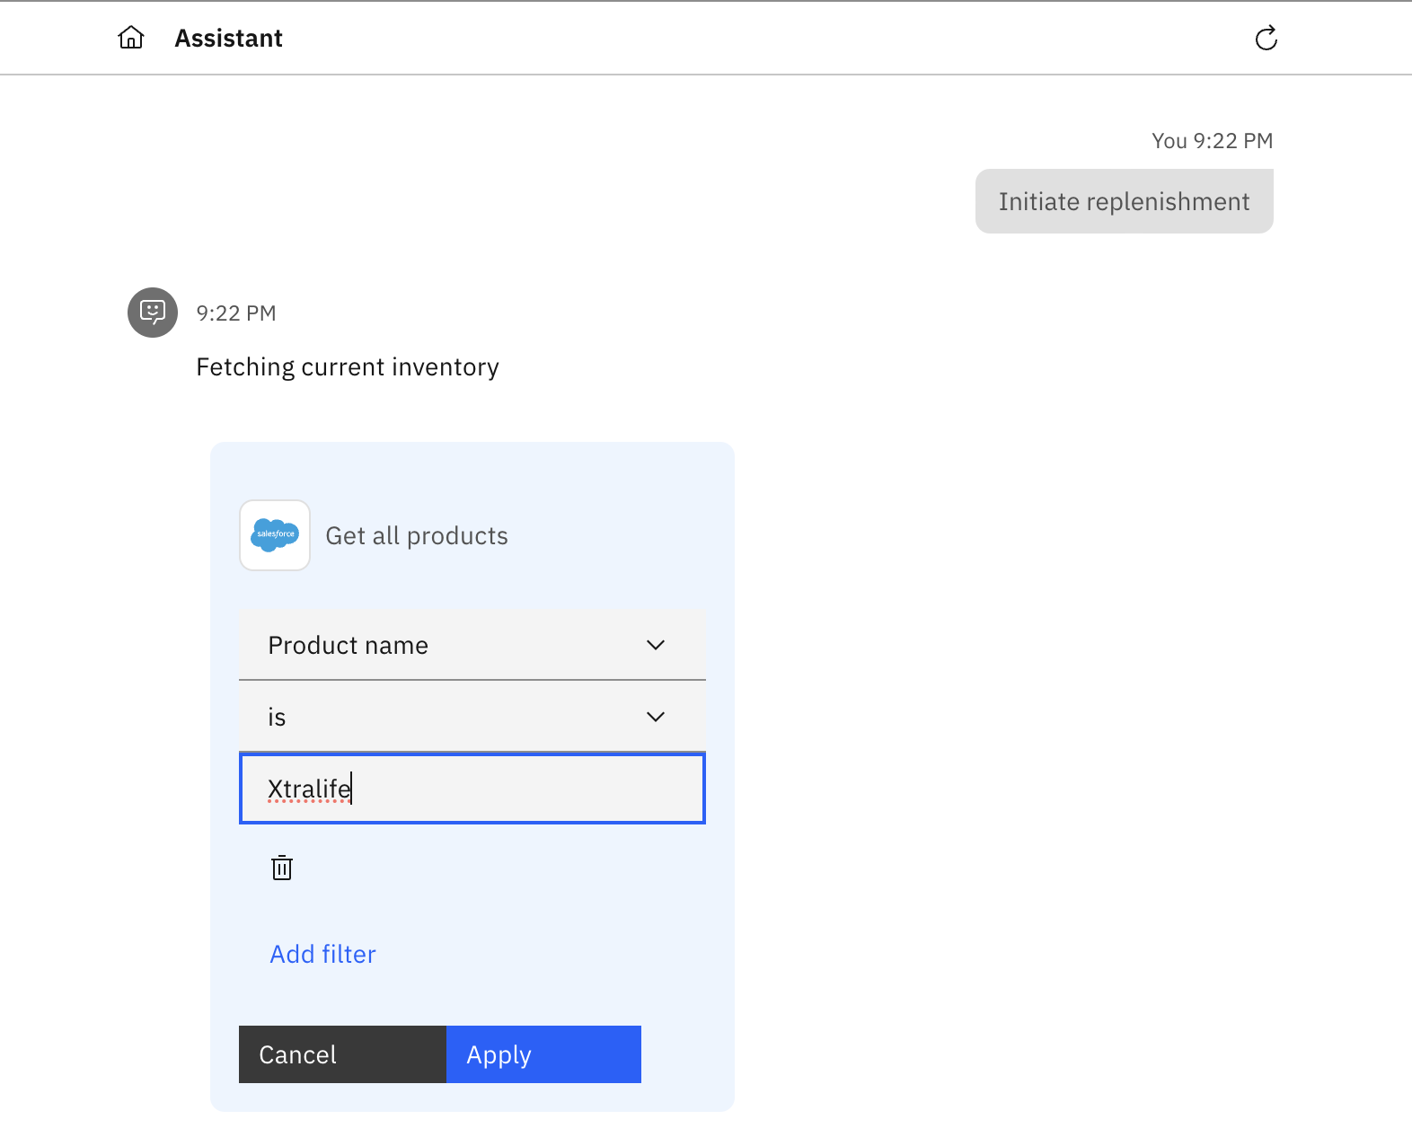

1. For getting historic sales, add the query: “What was the quantity sold last month for Xtralife?” and click Apply.

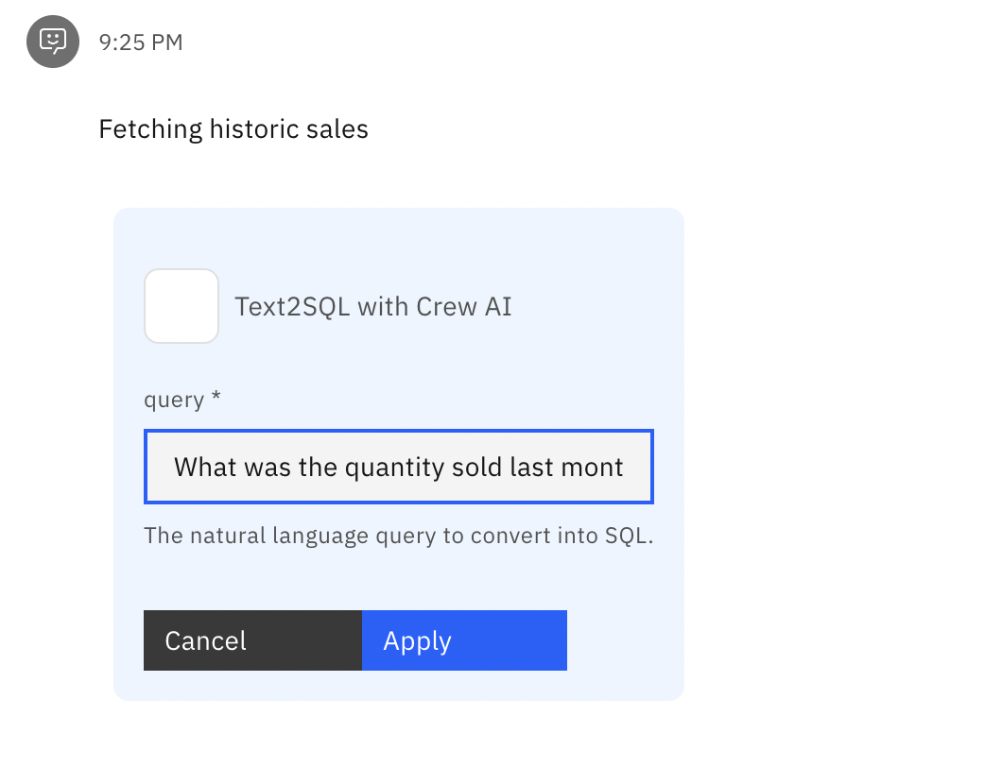

1. For getting forecasted sales, change the forecast window to 1, and click Apply.

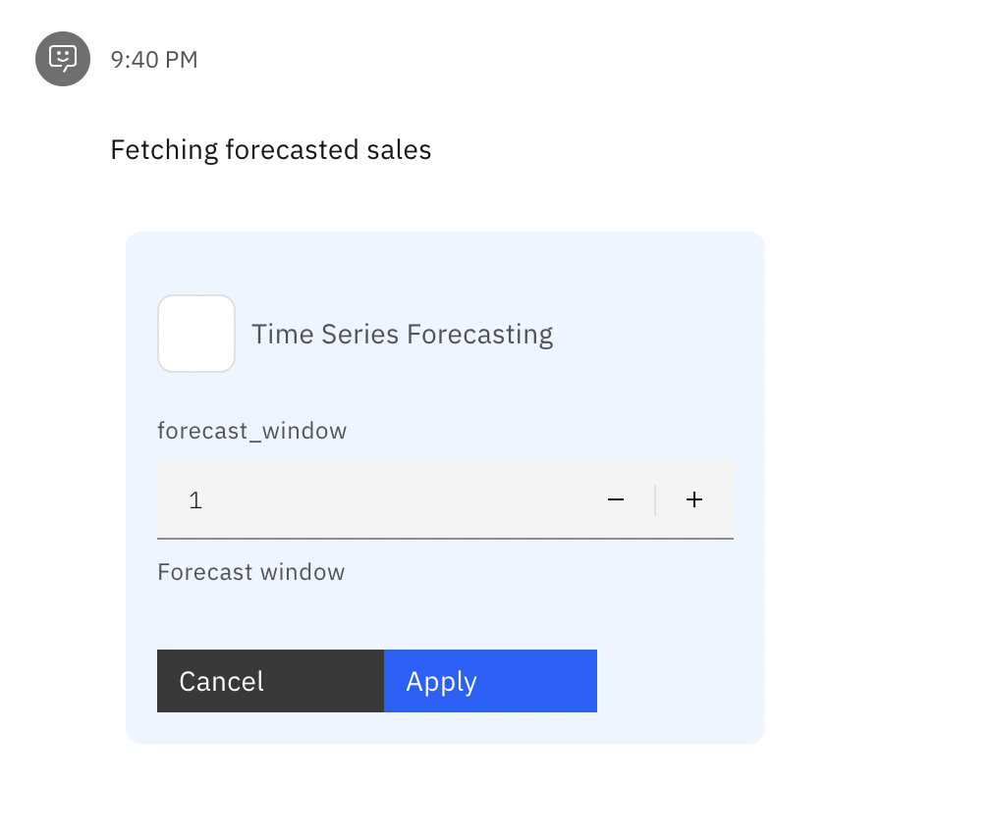

1. After getting the results for the forecast, the Assistant will prompt you to enter details. Enter the following details:
   1. Forecast Quantity next month: 3107
   2. Quantity sold last month: 3400
   3. Current Inventory: 1000
   4. And the confirm the details.

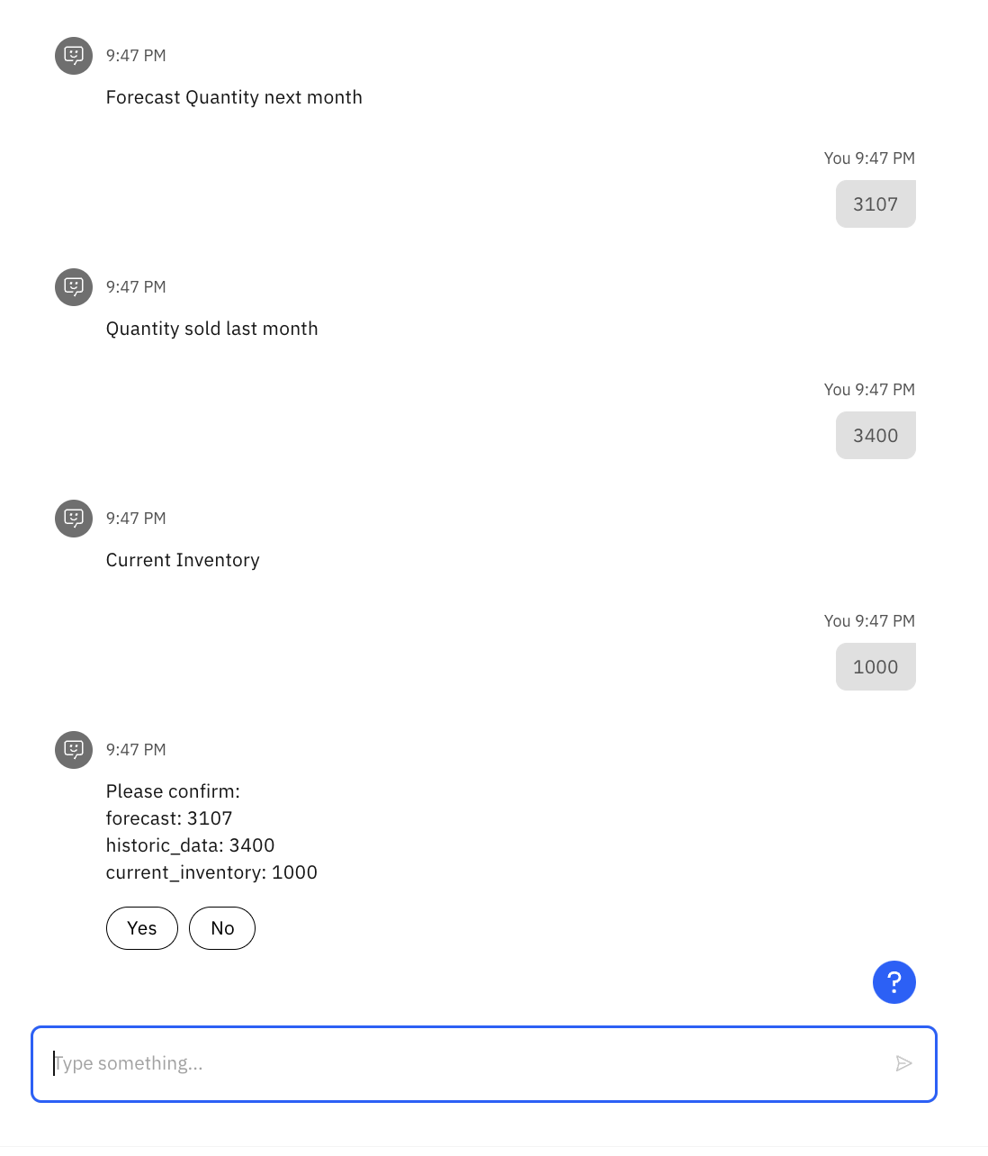

1. The Assistant will then trigger to calculate the optimal reorder quantity based on the above inputs and provide an output.

